|  |  |  |  |  |
| --- | --- | --- | --- | --- |
| **University of Central Punjab (FOIT)** | | | | |
|  | **Course:** | **Operating System Lab** | **Day:** | **Monday** |
| **Duration:** | **9:00 AM – 11:00 AM** | **Date:** | **December 4, 2023** |
| **Exam:** | **Mid-Term** | **Section:** | **BS-CS-F21-E10** |
|  | **Student Name:** _____________   **Student ID:** ______________________  **Instructions:**     * Understanding the question paper is also part of the exam. Make suitable ASSUMPTIONS. * Be sure to read questions carefully and answer all the questions. Use complete sentences and explain your answers. * Use of mobile phones or any other electronic device/gadget is strictly prohibited. If any student is found using a mobile phone during the examination, this would be considered a case of academic misconduct and treated as a UMC offence. Cell Phones should be turned off. * Leave your books/notes or any kind of helping material at the front of the examination room. * Any kind of cheat sheet if found will result in immediate disqualification from the Exam and **F** as the final grade in your course. | | | |

|  |  |  |  |
| --- | --- | --- | --- |
| **Q# 1** | **Q# 2** | **Q# 3** | **Q# 4** |
| **05** | **10** | **10** | **05** |
|  |  |  |  |

**Total Marks: 30**

Answer **ALL** questions.

(05 marks)

**Question 1:**

1. The **cat** command displays contents of an existing file. Use **cat** command and output *redirection operator* > in such a way that it would create a non-existing file, and send input from keyboard to that file. (Press Ctrl-D, when you finish)
2. Send the output of **ls -i** command to a existing or non-existing file.
3. Normally, the output of **cat** command goes to screen, use **cat** command in such a way that it will send its output to a file instead of screen.
4. The **who** command sends its output to standard output (screen), redirect standard output to the file **users**.
5. Create three files, **num**, **alpha**, and **numalpha**. Which contains numbers, alphabets, and alphanumeric respectively. Concatenate these three files in a single file **all**, using some suitable redirection operator.

**Question 2:**  (10 marks)

Write a C Program using fork system call to simulate the following scenario.

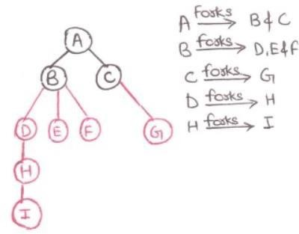

(10 marks)

**Question 3:**

Write C program to implement the given UNIX command”

grep “m” < input.txt | sort > output.txt

Question:4 (05 marks)

Write a program that takes numbers via command line arguments. The program then sends these numbers through pipe to its child process. The child process sorts those numbers in ascending order and sends back to the parent process. The parent process displays those numbers.

Example:

$./a.out 5 4 3 2 1

12345